

**Vision and Scope Document**

**for**

**Identifying Fake News in social media**

**Prepared by**

**Aleo Ralph C. De Leon**

**Marc Anthony Nares**

**Wyatt Holgado**

**03/28/2018**

Table of Contents

Revision History 2

1. Business Requirements 3

1.1. Background, Business Opportunity, and Customer needs 3

1.2. Business Objectives and Success Criteria 3

1.3. Business Risks 3

2. Vision of the Solution 4

2.1. Vision Statement 4

3. Major Features 4

3.1. Web Extension 4

3.2. IndexedDb Database 4

3.3. JavaScript 4

3.4. Image-based CAPTCHA 4

4. Assumptions and Dependencies 5

5. Scope and Limitations 6

5.1. Scope of Initial and Subsequent Release 6

6. Project Priorities 6

# Revision History

|  |  |  |  |
| --- | --- | --- | --- |
| **Name** | **Date** | **Reason For Changes** | **Version** |
|  |  |  |  |
|  |  |  |  |
| All members | 01/30/2018 | Initial Draft | 1.0 draft 1 |
| All members | 06/03/2018 | Final Draft | 2.0 |
| All members | 3/28/2018 | Revise Final Draft | 3.0 |

# Business Requirements

## Background, Business Opportunity, and Customer needs

Fake news is a deliberate misinformation or hoax that spreads via traditional print, broadcast news media or online social media (Novotny, 2017). It misleads people and makes the world less informed. It harms the community and the industry in an alarming level (Stecula, n.d.). Mocha Uson a secretary of the Presidential Communication Operation Office (PCOO) shared a post of a Duterte supporter which claimed that a young girl was murdered due to the drug problem in the Philippines. She was reportedly outraged as to why the Commission on Human Rights didn’t focus on the incident. However, the link showed a photo of a nine-year-old Brazilian girl who was raped and murdered in 2014. BBC called her on it and she later took down the post (ARIAS, 2017). With the way on how fake news is spreading, it would be ideal to have application that helps identify fake news online. Our web extension can include an advertising that gives the researchers business opportunities.

## Business Objectives and Success Criteria

The objectives of this study are to create a system that determines whether a link leads to a fake news article or not and to create a web extension that can identify whether a link clicked by a user leads to a fake news article or not.

## 1.3. Business Risks

* User acceptance - if the user sues the project for libel.
* Competition – More fake news identifier online.

# Vision of the Solution

## Vision Statement

This project will help social media users to be aware of what they read on the internet and to lessen being tricked by fake news.

# Major Features

### Web Extension

Extensions are bits of code that modify the functionality of a web browser. They are written using standard Web technologies - JavaScript, HTML, and CSS - plus some dedicated JavaScript APIs. Among other things, extensions can add new features to the browser or change the appearance or content of particular websites. Basically, the researchers will create an extension that can identify fake news in social media sites.

### IndexedDb Database

A collection of data is called a Database. In order to manage a data in a database, it will need to have a Database Management System (DBMS). DBMS can help the user interact with the database itself and it can also help them to handle and capture the data. The researchers will use IndexedDb. IndexedDB is a low-level API for client-side storage of significant amounts of structured data, including files/blobs. This API uses indexes to enable high performance searches of this data.

### JavaScript

JavaScript is a programming language that enables you to create dynamically updating content, control multimedia, animate images, and pretty much everything else. The researchers will use this language to create an extension.

### Image-based CAPTCHA

CAPTCHA stands for Completely Automated Public Turing Test to tell Computers and Humans Apart. Using this feature, it will provide security through challenge tests based on images to verify users if it is a human or a bot.

# Assumptions and Dependencies

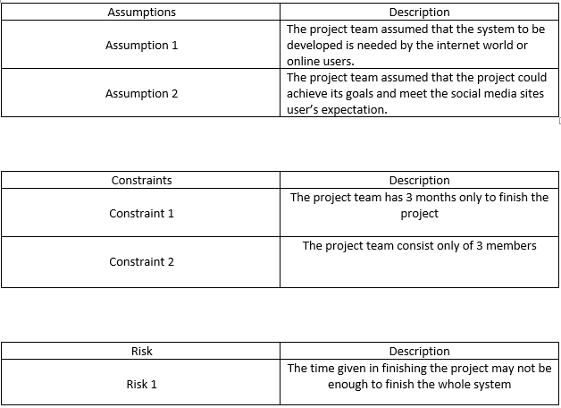

# Scope and Limitations

The study is about identifying fake news. The researchers will use web programming languages to create a web extension for identifying fake news. The gathered datasets will come from two online websites (kaggle.com, Opensources) the web extension will only work on the latest and upcoming versions Google Chrome and it will not work on any other browsers. This study is only limited in identifying fake news sites.

## Scope of Initial and Subsequent Release

The web extension will identify fake news when the user chooses to run it. The user will benefit from using the program because it is free.

# Project Priorities

|  |  |  |  |
| --- | --- | --- | --- |
| **Dimension** | **Driver** | **Constraint** | **Degree of Freedom** |
|  | **(state objective)** | **(state limits)** | **(state allowable range)** |
|  |  |  |  |
| Schedule | release 1.0 to be |  |  |
|  | available by 10/1, |  |  |
|  | release 1.1 by 12/1 |  |  |
|  |  |  |  |
| Features |  |  | 70-80% of high priority |
|  |  |  | features must be included in |
|  |  |  | release 1.0 |
|  |  |  |  |
| Quality |  |  | 90-95% of user acceptance |
|  |  |  | tests must pass for release |
|  |  |  | 1.0, 95-98% for release 1.1 |
|  |  |  |  |
| Staff | Project manager is half-time developer, developer is half-time documentor and documentor is always available. | maximum team size is |  |
|  |  | 2 developers + 1 |  |
|  |  | documentor |  |
|  |  |  |  |
| Cost |  |  | budget overrun up to 15% |
|  |  |  | acceptable without executive |
|  |  |  | review |
|  |  |  |  |